Home Assignments – week 2

1) S17 - DOM to Selenium Code.
DOM to Selenium Code: Give the DOM as input, Leaftaps login, and generate the Playwright Typescript/Selenium Java, or anything of your choice, with different models using temperature

{
"messages": [
{
"role": "user",
"content": "Extract the below given DOM : \n\n<input type=\"text\" class=\"inputBox\" name=\"companyName\" size=\"30\" maxlength=\"100\" id=\"createLeadForm_companyName\">\n<input type=\"text\" class=\"inputBox\" name=\"lastName\" size=\"30\" maxlength=\"100\" id=\"createLeadForm_lastName\">\n<input type=\"text\" class=\"inputBox\" name=\"firstName\" size=\"30\" maxlength=\"100\" id=\"createLeadForm_firstName\">\n<input type=\"submit\" class=\"smallSubmit\" name=\"submitButton\" value=\"Create Lead\" id=\"ext-gen630\"> and provide me the selenium java code. Instructions: Do not use ID if the value has number in it. Provide only java code and no explanations needed"
}
],
"model": "meta-llama/llama-4-scout-17b-16e-instruct",
"temperature": 0.1
}

import org.openqa.selenium.By;
import org.openqa.selenium.WebDriver;
import org.openqa.selenium.WebElement;
import org.openqa.selenium.chrome.ChromeDriver;

public class Main {
public static void main(String[] args) {

System.setProperty("webdriver.chrome.driver", "/path/to/chromedriver");
WebDriver driver = new ChromeDriver();
driver.get("your_website_url");
WebElement companyNameInput = driver.findElement(By.name("companyName"));
WebElement lastNameInput = driver.findElement(By.name("lastName"));
WebElement firstNameInput = driver.findElement(By.name("firstName"));
WebElement submitButton = driver.findElement(By.className("smallSubmit"));
companyNameInput.sendKeys("Company Name");
lastNameInput.sendKeys("Last Name");
firstNameInput.sendKeys("First Name");
submitButton.click();
driver.quit();
}
}
Example 2:
{
"model": "openai/gpt-oss-120b",
"temperature": 0.3,
"messages": [
{
"role": "system",
"content": "You are a senior QA automation engineer. Generate clean, production-ready automation code."
},
{
"role": "user",
"content": "Generate selinium java code automation code using Page Object Model with assertions.\n\nAPPLICATION:\nName: Leaftaps\nURL: http://leaftaps.com/opentaps/control/main\nPage: Login\n\nDOM ELEMENTS:\n1. Username\n - type: input\n - locator: id=username\n\n2. Password\n - type: input\n - locator: id=password\n\n3. Login Button\n - type: button\n - locator: class=decorativeSubmit\n\nTEST FLOW:\n- Navigate to login page\n- Enter username\n- Enter password\n- Click login button\n- Validate successful login\n\nOUTPUT REQUIREMENTS:\n- Framework: Playwright\n- Language"
}
]
}

package com.leaf.pages;

import com.microsoft.playwright.*;

public class LoginPage {

private final Page page;
private final String baseUrl = "http://leaftaps.com/opentaps/control/main";

private final Locator usernameInput;
private final Locator passwordInput;
private final Locator loginButton;

public LoginPage(Page page) {
this.page = page;
this.usernameInput = page.locator("#username");
this.passwordInput = page.locator("#password");
this.loginButton = page.locator("button.decorativeSubmit");
}

public LoginPage open() {
page.navigate(baseUrl);
usernameInput.waitFor(
new Locator.WaitForOptions()
.setState(WaitForSelectorState.VISIBLE)
);
return this;
}

public LoginPage setUsername(String username) {
usernameInput.fill(username);
return this;
}

public LoginPage setPassword(String password) {
passwordInput.fill(password);
return this;
}

public LoginPage clickLogin() {
loginButton.click();
return this;
}

public LoginPage loginAs(String username, String password) {
return open()
.setUsername(username)
.setPassword(password)
.clickLogin();
}

public Locator getWelcomeHeader() {
return page.locator("h2.welcome");
}
}

2. S21 - MultiLingual
Ask to generate any content in diff languages (Japanese,Tamil,Telugu of your choice) and check whether the ouput is correct .
You can verify the output in 2 ways
1)Copy the output and paste in chatgpt qwen or any chatagent for translation
2)You can also send the response generated in a langauage say Japanese,Tamil or Telugu) as request to the S21 - MultiLingual API in postman collection and verify it
(Use at least 2 different models from groq)
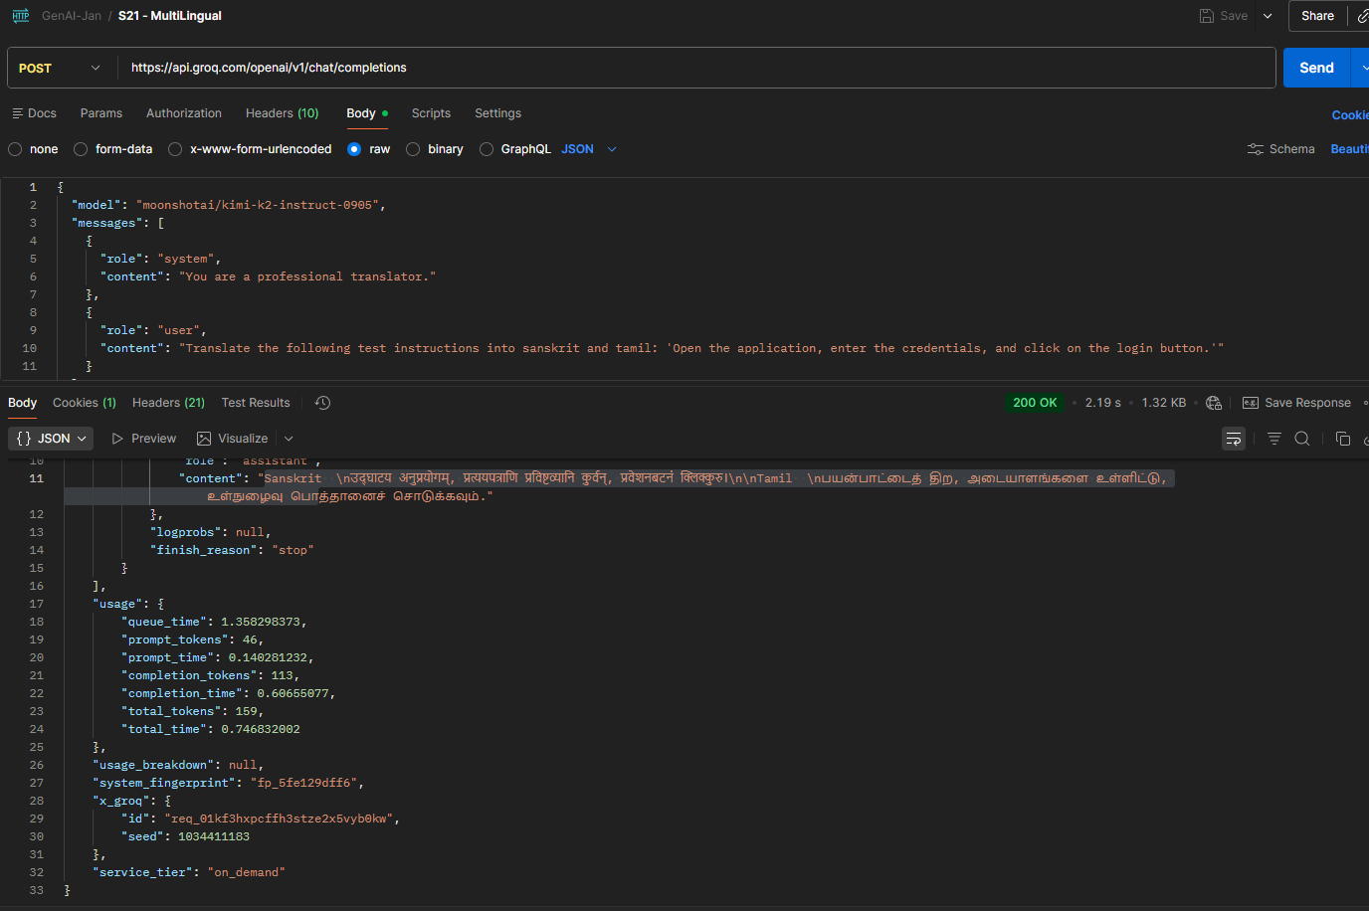
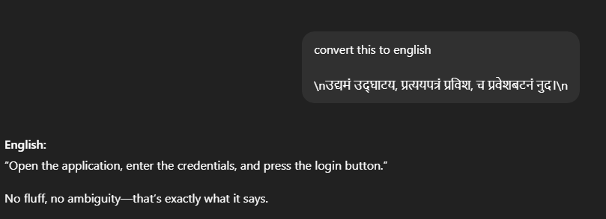

Model: openai/gpt-oss-120b

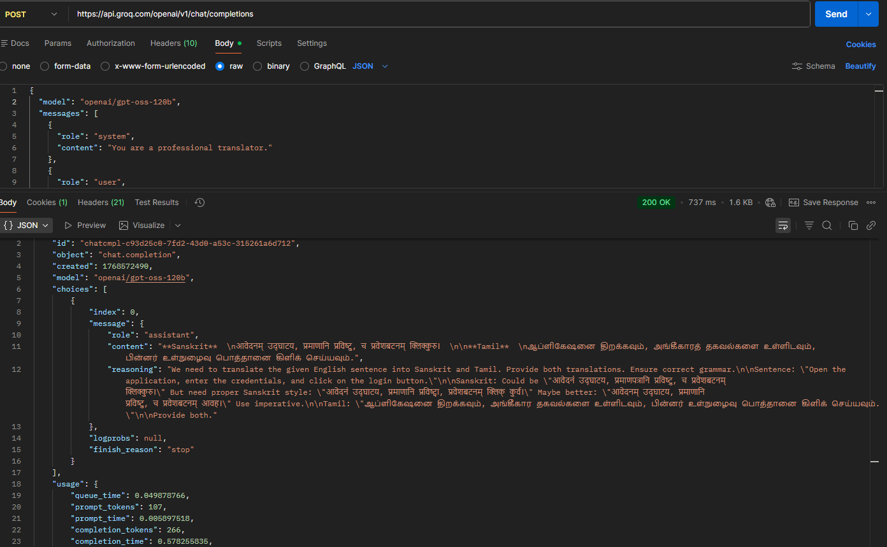
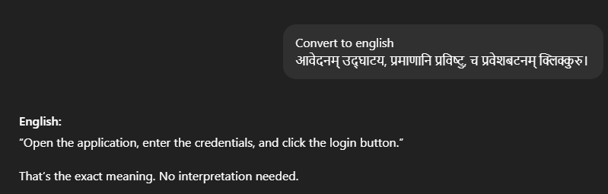

3) S16-Transcriptions
Try to generate the meeting summary of your office meeting or any files of your choice, and extract the text
(Use whisper-large-v3 and also the whisper-large-v3 Turbo)
Response using whisper-large-v3
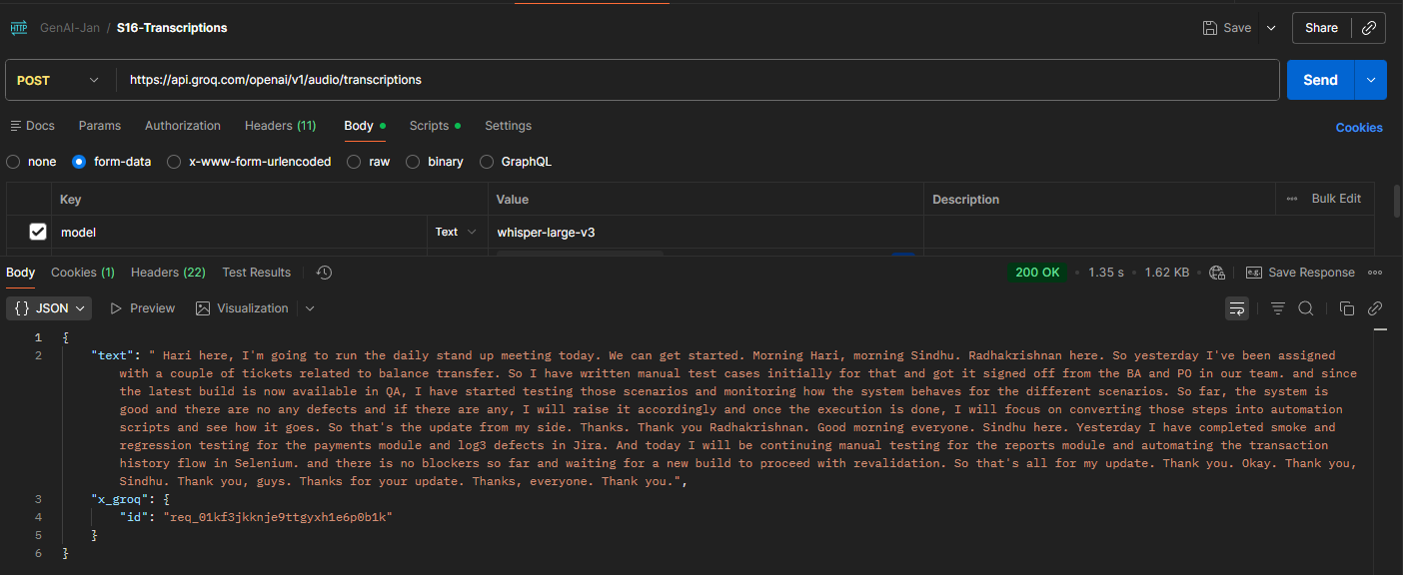

OUTPUT:
{
"text": " Hari here, I'm going to run the daily stand up meeting today. We can get started. Morning Hari, morning Sindhu. Radhakrishnan here. So yesterday I've been assigned with a couple of tickets related to balance transfer. So I have written manual test cases initially for that and got it signed off from the BA and PO in our team. and since the latest build is now available in QA, I have started testing those scenarios and monitoring how the system behaves for the different scenarios. So far, the system is good and there are no any defects and if there are any, I will raise it accordingly and once the execution is done, I will focus on converting those steps into automation scripts and see how it goes. So that's the update from my side. Thanks. Thank you Radhakrishnan. Good morning everyone. Sindhu here. Yesterday I have completed smoke and regression testing for the payments module and log3 defects in Jira. And today I will be continuing manual testing for the reports module and automating the transaction history flow in Selenium. and there is no blockers so far and waiting for a new build to proceed with revalidation. So that's all for my update. Thank you. Okay. Thank you, Sindhu. Thank you, guys. Thanks for your update. Thanks, everyone. Thank you.",
"x_groq": {
"id": "req_01kf2r0n10eqt994h7ncd4edbm"
}
}

RESPONSE USING whisper-large-v3 Turbo
OUTPUT:
{
"text": " I am going to run the daily stand-up meeting today. We can get started. Morning, Ari. Morning, Sindhu. Radhakrishnan here. So yesterday I have been assigned with a couple of tickets related to balance transfer. So I have written manual test cases initially for that and got it signed off from the BA and PO in our team. And since the latest build is now available in QA, I have started testing those scenarios and monitoring how the system behaves for the different scenarios. So far, the system is good and there are no any defects. And if there are any, I will raise it accordingly. And once the execution is done, I will focus on converting those steps into automation scripts and see how it goes. So that's the update from my side. Thanks. Thank you, Radhakrishna. Good morning, everyone. Sindhu here. Yesterday, I have completed smoke and regression testing for the payments module and log 3 defects in Jira. And today, I will be continuing manual testing for the reports module and automating the transaction history flow in Selenium. And there is no blocker so far and waiting for a new build to proceed with revalidation. So that's all for my update. Thank you. Okay. Thank you, Sindhu. Thank you, guys. Thanks for your update. Thanks, everyone. Thank you.",
"x_groq": {
"id": "req_01kf2rb72fee0vdnxgcwx7axws"
}
}

4) S09 - TextFromImage-Url
Use the vision model to extract the text from multilingual
